Newsletter
Issue 1

8 September 2023

Dear Parents and Carers

I would like to welcome everyone back to school and say a huge well done to everyone. Everyone looks so smart in their uniforms and I have seen lots of happy faces on the playground in the mornings.

Our new Reception class have come in beautifully and look really ready to learn and have fun. We have had some new starters in different year groups and they too have settled in really quickly.

We have some new staff to say hello to this term. Miss Yusuf is teaching in Year 3 and Miss Wright and Miss Glenn have joined our fantastic team of teaching assistants. Mrs Davies has kindly taken on the role of interim Assistant Head Teacher.

We are sorry to be saying goodbye to Mrs Flood, our family support worker, who is starting another role nearer to her home in Southampton, supporting families of Nursery aged children. We will miss her but have learnt lots from her and we wish her all the best. If you would like any family support or are worried about anything do not hesitate to contact Mrs Davies or myself through the admin office.

We are very pleased to announce that Mrs McDowall in Nursery passed her
Level 3 Early Years Educator Apprenticeship.
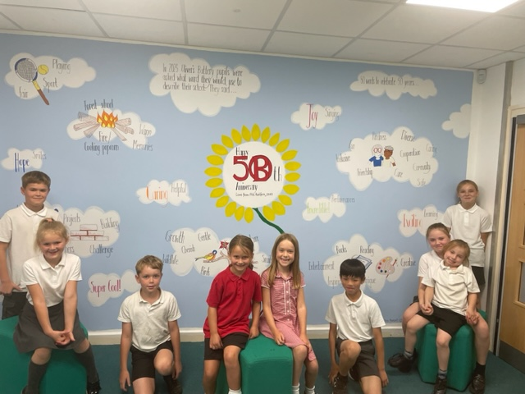
We came back to school to a lovely present. Mrs Redfern had organized a beautiful mural to be painted which celebrates all of the positive things that our children say about our school.

Attendance
As a school, our attendance has dropped significantly this year. Our absence rate is 2.5% higher than national average, which is the equivalent to 641 more missed sessions in our school than a national cohort. This is having an impact on outcomes for pupils. One of the reasons for this is the number of holidays that families are taking during term time. All holiday requests are unauthorised, and fines are issued. Families are only allowed to be fined once. Further unauthorised absences may result in legal action. I cannot stress to you enough the importance of good attendance in school for pupils' wellbeing, academic progress and outcomes. To be clear the school does not receive any money from Penalty Notices issued, and we follow Hampshire expectations. Because of the dip, attendance will be part of the School Improvement Plan next year and a real focus for leaders. Leaders will continue to challenge and work with families on low attendance to ensure that we are working together to get the best for pupils.

PE Kits
Please can you ensure that the children have their PE kits in school during term time – they can be taken home to be washed either at weekends or half term.

The school would be very grateful of any donations of PE kits or trainers.

School 50th Anniversary
The school’s 50th Anniversary Festival is taking place next Saturday, 16 September – 11.30 – 3.30pm. We are trying to get as many past pupils and staff to join us to celebrate. There are lots of lovely things planned live music, bar, bbq, inflatables, market stalls and lots more. Please find attached a flyer from the PTA. We look forward to seeing you all there!

Mental Health Support Team
Please find attached a flyer from Mental Health Support Team based in Winchester whose role is to work with schools, young people and families.

They are also holding online webinar for parents and carers of primary-aged children offering information around what anxiety is and tips for how to support your child. Please find attached a flyer with more information.

Hampshire County Youth Choir
Hampshire County Youth Choir are looking to recruit new members and are having a taster session on Friday 15 September 6pm for Year 2 – 6. These are taking place at United Church, Jewry Street, Winchester. For more information or to sign up follow the link: Hampshire County Youth Choirs Sing Alongside Evening – Friday 15th September 2023 (google.com).

School Uniform Shop
Our school uniform supplier – Direct4logos who are based in Romsey will be closed on Saturday 9 September due to road closures for the Romsey show.

Weeke Fun Weekend
Weeke Community Centre are holding a family fun weekend – Saturday 9 September 2-6pm and Sunday 10 September 12-4pm with live music, funfair games, food stalls and lots more – free entry – everyone welcome.

Christmas Card Project
It seems very early to be talking about Christmas but the PTA are once again running a Christmas Design Project. This is to encourage the children with their creativity and design skills. Over the next couple of weeks the children will be designing their own Christmas design which can be professionally printed to produce Christmas Cards, Gift Labels, Wrapping Paper and mugs which you are able to order. This idea raises much needed funds for the PTA and in turn, the school.

The children will be bringing their artwork home and if you would like to place an order this can be done online – the artwork is then returned to the school to be sent off and used to produce the cards etc.

St. Cross Garden Society Annual Show
This Saturday, 9th September, the Garden Society will be holding their annual show in St. Faith’s Hall, Back Street, St. Cross from 2pm. They will have hundreds of exhibits, such as: fruit, vegetable and flowers, floral art, cookery, crafts, photography, etc. They will also have a plant and produce stall, refreshments and a raffle. Some of our Edible Garden team will be there too and would love to see you!
Learning Behaviours
We have held this week’s Learning Behaviours assembly. This is where each teacher chooses a child/children that has demonstrated the chosen learning behaviour of the week. The teacher shares with everyone what the child has done and then we all celebrate their achievement. This term we are looking at respect. The children who were chosen this week were:

Year One Leo B
Year Two Alex B
Year Three Jack A
Year Four Jack R
Year Five Olivia T
Year Six Paris C

School Lunches
Thank you to everyone for settling their lunch accounts, however the lunch debts are now at an all-time high - please could you ensure that your account is kept up to date. For your information the money owed per class is as follows:-

Hares £ 102.75
Foxes £ 208.65
Herons £ 246.50
Kingfishers £ 272.23
Ospreys £ 172.70
Nursery £ 184.80

From September your child will not be able to order a school lunch if the debt is above £10.00 – if the debt is over £10.00 they will need to bring in a packed lunch. Please can you arrange to clear your Lunch accounts before next week.

If you would like an up to date statement of your child’s account please contact the Admin Team. If you have not yet registered to pay online via Scopay and would like a copy of your login details please email us and we will be happy to help. We would appreciate it if all accounts, including any outstanding Breakfast Club and After School Club accounts, could be settled as soon as possible. Please ensure that your After School Club Account is up to date as we employ extra staff for this club. If you would like an up to date statement please contact the school office.

Thank you for your continued support.

Yours faithfully

Mrs Bordoli
Interim Headteacher

Dates for your diary (new dates in red)
50th Anniversary Festival 11.30 – 3.30pm 16 September 2023
Open Morning 22 September 2023
Open Morning 19 October 2023
Inset Day 20 October 2023
Open Morning 29 November 2023
Open Morning 5 January 2023
Inset Day 19 February 2024
Inset Day 28 June 2024
Inset Day 1 July 2024

